11. Develop a system using UML for Conference Management System.

Use case diagram:

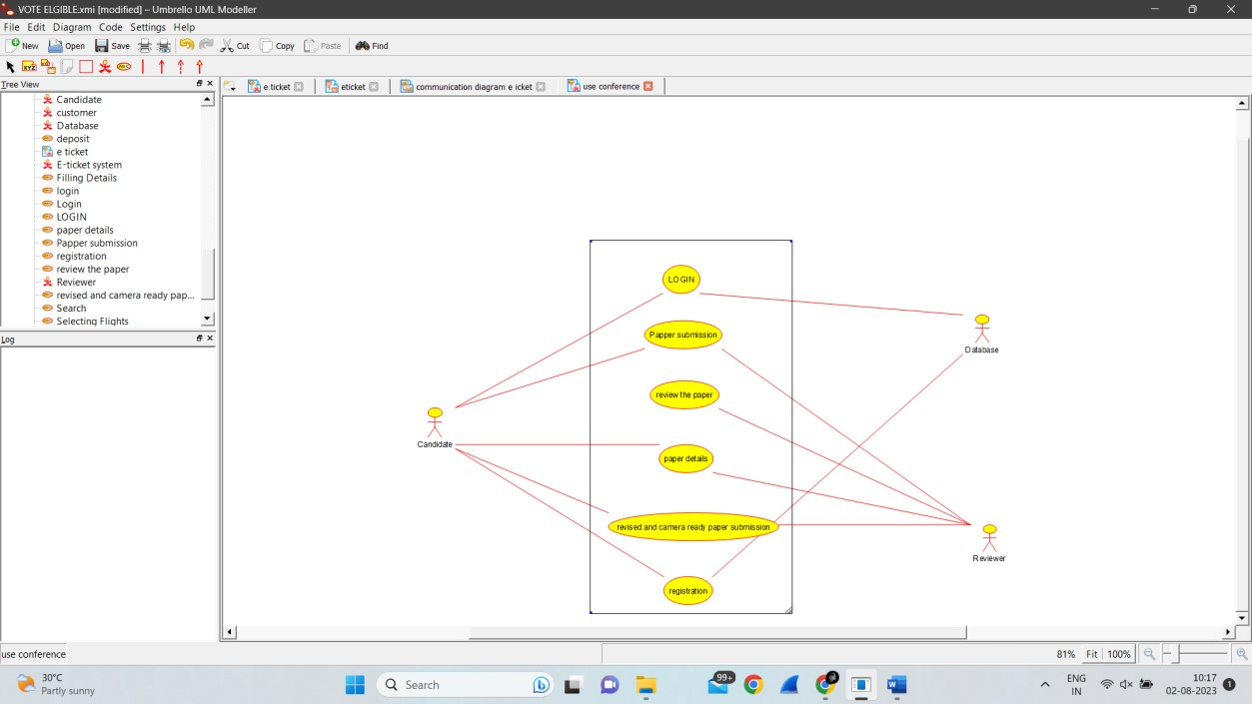

Activity diagram:

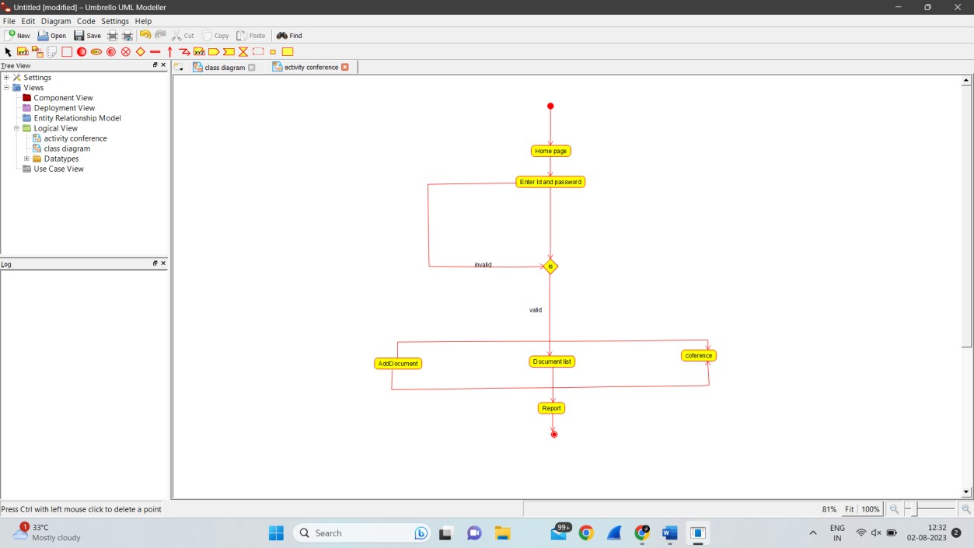

Collaboration diagram:

